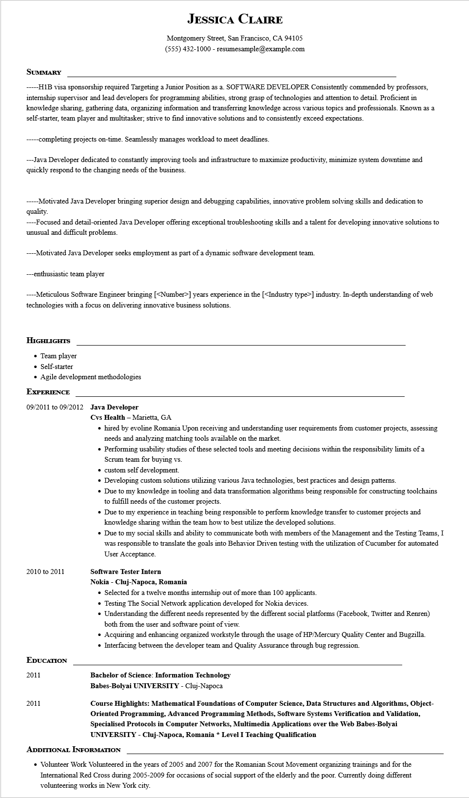
JESSICA CLAIRE
Montgomery Street, San Francisco, CA 94105
(555) 432-1000 - resumesample@example.com
SUMMARY
-----H1B visa sponsorship required Targeting a Junior Position as a. SOFTWARE DEVELOPER Consistently commended by professors, internship supervisor and lead developers for programming abilities, strong grasp of technologies and attention to detail. Proficient in knowledge sharing, gathering data, organizing information and transferring knowledge across various topics and professionals. Known as a self-starter, team player and multitasker; strive to find innovative solutions and to consistently exceed expectations.
-----completing projects on-time. Seamlessly manages workload to meet deadlines.
---Java Developer dedicated to constantly improving tools and infrastructure to maximize productivity, minimize system downtime and quickly respond to the changing needs of the business.
-----Motivated Java Developer bringing superior design and debugging capabilities, innovative problem solving skills and dedication to quality.
----Focused and detail-oriented Java Developer offering exceptional troubleshooting skills and a talent for developing innovative solutions to unusual and difficult problems.
----Motivated Java Developer seeks employment as part of a dynamic software development team.
---enthusiastic team player
----Meticulous Software Engineer bringing [<Number>] years experience in the [<<Industry type>] industry. In-depth understanding of web technologies with a focus on delivering innovative business solutions.
HIGHLIGHTS
• Team player
• Self-starter
• Agile development methodologies
EXPERIENCE
09/2011 to 09/2012 Java Developer
2010 to 2011
Cvs Health - Marietta, GA
⚫ hired by evoline Romania Upon receiving and understanding user requirements from customer projects, assessing needs and analyzing matching tools available on the market.
• Performing usability studies of these selected tools and meeting decisions within the responsibility limits of a Scrum team for buying vs.
⚫ custom self development.
• Developing custom solutions utilizing various Java technologies, best practices and design patterns.
• Due to my knowledge in tooling and data transformation algorithms being responsible for constructing toolchains to fulfill needs of the customer projects.
• Due to my experience in teaching being responsible to perform knowledge transfer to customer projects and knowledge sharing within the team how to best utilize the developed solutions.
• Due to my social skills and ability to communicate both with members of the Management and the Testing Teams, I was responsible to translate the goals into Behavior Driven testing with the utilization of Cucumber for automated User Acceptance.
Software Tester Intern
Nokia - Cluj-Napoca, Romania
• Selected for a twelve months internship out of more than 100 applicants.
• Testing The Social Network application developed for Nokia devices.
• Understanding the different needs represented by the different social platforms (Facebook, Twitter and Renren) both from the user and software point of view.
• Acquiring and enhancing organized workstyle through the usage of HP/Mercury Quality Center and Bugzilla.
• Interfacing between the developer team and Quality Assurance through bug regression.
EDUCATION
2011
Bachelor of Science: Information Technology Babes-Bolyai UNIVERSITY - Cluj-Napoca
2011
Course Highlights: Mathematical Foundations of Computer Science, Data Structures and Algorithms, Object- Oriented Programming, Advanced Programming Methods, Software Systems Verification and Validation, Specialised Protocols in Computer Networks, Multimedia Applications over the Web Babes-Bolyai UNIVERSITY - Cluj-Napoca, Romania * Level I Teaching Qualification
ADDITIONAL INFORMATION
• Volunteer Work Volunteered in the years of 2005 and 2007 for the Romanian Scout Movement organizing trainings and for the International Red Cross during 2005-2009 for occasions of social support of the elderly and the poor. Currently doing different volunteering works in New York city.

